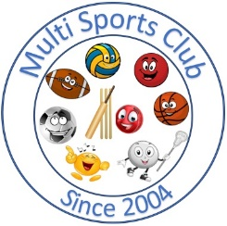

Multi Sports Club

[www.multisportsclub.org.uk](http://www.multisportsclub.org.uk)

Reg Charity: 1109962

Phone: 07814135565

# Equity policy statement

 This club is committee to ensuring that equity is incorporated across all aspects of its development. In doing so it acknowledges and adopts the following Sport England definition of sports equity:

**Sports equity is about fairness in sport, equality of access, recognizing inequalities and taking steps to address them. It is about changing the culture and structure of sport to ensure it becomes equally accessible to everyone in society.**

 The club respects the rights, dignity and worth of every person and will treat everyone equally within the context of their sport, regardless of age, ability, gender, race, ethnicity, religious belief, sexuality or social/economic status.

 The club is committed to everyone having the right to enjoy their sport in an environment free from threat of intimidation, harassment and abuse.

 All club members have a responsibility to oppose discriminatory behaviour and promote equality of opportunity.

* The club will deal with any incidence of discriminatory behaviour seriously, according to club disciplinary procedures.

August 2016

Reviewed June 2024



Multi Sports Club

[www.multisportsclub.org.uk](http://www.multisportsclub.org.uk)

Reg Charity: 1109962

Phone: 07814135565

**Being Fair to everyone**

 We think our club should be open to everyone

 We think everyone should be treated equally regardless of age, ability, gender, race, ethnicity, religious belief, sexuality or social/economic status

 We think you should enjoy sport without feeling intimidated harassed or being abused

 Tell someone if you think someone is not being fair.

 The club will take you seriously and do something about it

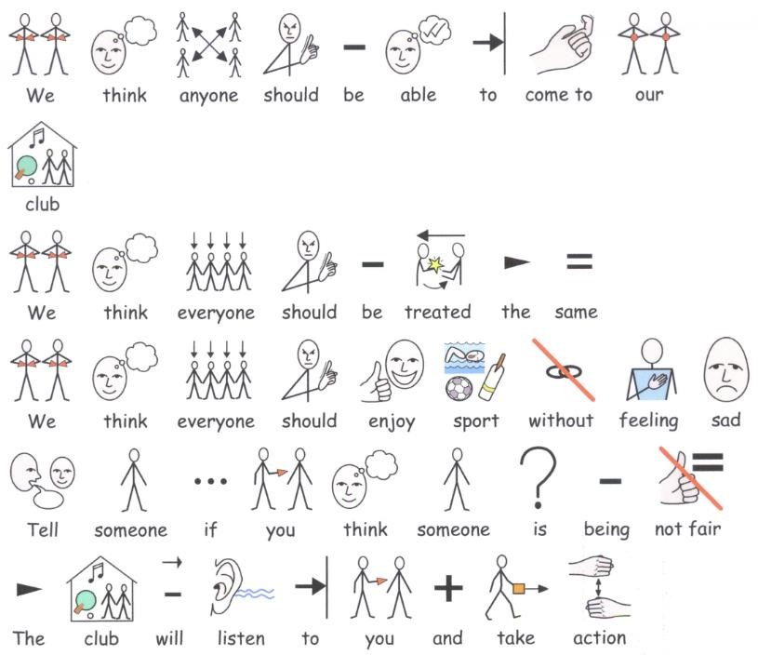August 2016 Reviewed June 2024