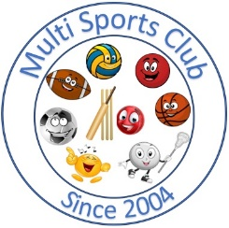

Multi Sports Club

[www.multisportsclub.org.uk](http://www.multisportsclub.org.uk)

Reg Charity: 1109962

Phone: 07814135565

# Code of Conduct for parents/carers

 Help club members to enjoy their sport

 Encourage learning the rules and playing within them

 Set a good example by recognising fair play and applauding good performances of all, not just results

 Encourage and guide club members to accept responsibility for their own performance and behaviour to the best of their ability

 Discourage unfair play and arguing with coaches and volunteers

 Never force anyone to take part in sport

 Publicly accept judgements of coaches and club committee members

 Never punish or belittle anyone for losing or making mistakes.

 Use correct and proper language at all times

 Ensure you arrive on time for coaching sessions

 Ensure club fees are paid promptly at the start of each programme or session

 Provide appropriate clothing for the club member to wear during a session

 Discuss any concerns with the coach or a committee member

January 2014

Reviewed June 2024