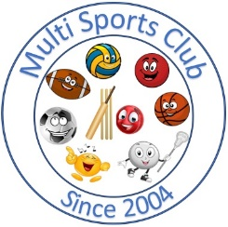

Multi Sports Club

[www.multisportsclub.org.uk](http://www.multisportsclub.org.uk)

Reg Charity: 1109962

Phone: 07814135565

# Code of Conduct for coaches, assistants and volunteers

 Consider the well-being and safety of club members before the development of performance.

 Develop an appropriate working relationship with club members, coaches and other volunteers, based on mutual trust and respect.

 Follow all instructions given by the coach and the club.

 Encourage club members to value their performances and not just results.

 Encourage and guide club members to accept responsibility for their own performance and behaviour.

 Encourage and guide club members to participate in the activities to the best of their ability.

 Promote the positive aspects of the sport (e.g. fair play).

 Set a good example to club members by adopting a consistently high standard of behaviour and appearance.

 Do not influence club members to obtain personal benefit or reward.

 Never condone rule violations, rough play or the use of prohibited substances.

 Report any concerns to the coach or to a club committee member.

* Treat as confidential any personal information gained about club members

January 2014

Reviewed June 2025