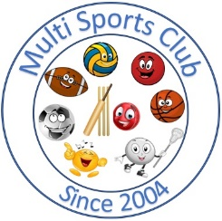

Multi Sports Club

[www.multisportsclub.org.uk](http://www.multisportsclub.org.uk)

Reg Charity: 1109962

Phone: 07814135565

# Code of Conduct for club members

Multi Sports Club is fully committed to safeguarding and promoting the well being of all its members.

The club believes that it is important that members, coaches, administrators and parents associated with the club should, at all times, show respect and understanding for the safety and welfare of others.

Therefore, members are encouraged to be open at all times and to share any concerns of complaints that they may have about any aspect of the club with:

Sarah-Jane Davies (Secretary) 02380 696833 07810 867309

Susan Perrin (Treasurer) 02380 487789 07814135565

As a member of the Multi Sports Club, you are expected to abide by the following code of practice:

 All members must respect the rights, dignity and worth of all participants regardless of age, gender, ability, race, cultural background, religious beliefs or sexual identity.

 All members must play within the rules and respect officials and their decisions.

 Members should keep to agreed timings for training or inform the club if they are going to be late.

 Members must wear suitable kit for training and match sessions, as agreed with the coach. Loose fitting, comfortable sports clothes and trainers are suitable for most sports activities. Shin guards are recommended for football sessions. Strong footwear and appropriate clothing for outdoor activity centre sessions.

Members must pay any fees for training or events promptly.



No smoking is allowed on club premises or during any activities No alcohol or drugs of any kind may be consumed during activities. (excludes any essential medication required)

Continued overleaf

January 2014 (Reviewed June 2025)

