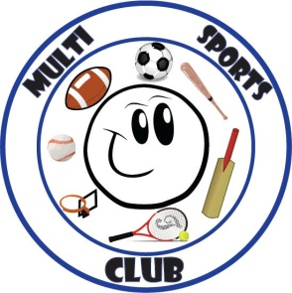
Multi Sports Club
www.multisportsclub.org.uk
Reg Charity No: 1109962

Coach agreement form

All coaches working with Multi Sports Club are encouraged to work to high standards and adopt recognised best practice where possible. In addition to their own standards of practice, all club coaches should be aware of and adopt Multi Sports Club’s own:
- Health and Safety policy.
- Codes of Conduct for coaches, volunteers, club members and parents/carers.
- Diversity and Inclusion policy.
- Child, Young Person and Vulnerable Adults Protection Policy and procedures.
The club will ensure that each policy and Code of Conduct is available to download from the web site, or printed if requested. The club will listen to and respond to matters brought to its attention in relation to the activities and will support, where possible, any training needs.
Signed on behalf of Multi Sports Club

Signed: Date:

Name:

I am familiar with Multi Sports Club’s policies and standards of practice named above and will adopt these in my work with the club. I accept the responsibilities outlined in the attached task description, and will treat as strictly confidential all personal information provided for the purposes of running coaching session for the club.

I have a copy of, or access via the web site, to the club’s policies/documents listed above

I have completed a membership form.

Signed: Date:

Name:

